Amazon EC2 Instance Introduction

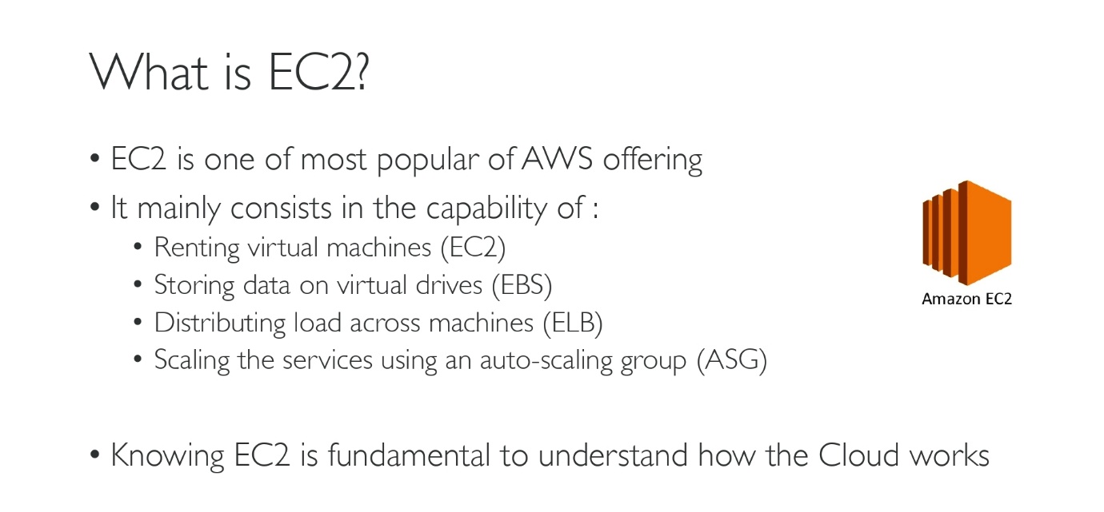

How to launch an EC2 instance:

1. Log into the console using your IAM account.
2. In the Services select EC2 link.
3. Select the region.
4. Click Launch Instances.
5. Choose and AMI (Amazon Machine Image) or OS.
6. Select for Linux 2 AMI (for this course).
7. It’s a free tier eligible instance, which is good for you and me.
8. Select type ‘t2.micro’.
9. Click Next: Configure Instance Details.

No of instances: 1

1. Click Storage
2. Min storage limit is 8GB
3. Click Add Tags
4. Click add tag: Give a name and value
5. Click Configure Security Group
   1. Select ‘Create new security group’
   2. Give a name
   3. Give description
6. Click ‘Review and Launch’.
7. Don’t worry about the warning.
8. Finally click on ‘Launch’.
9. Key Pair: gives you access into the instance you created.
10. Create a new keypair with a name and download this.

Instance Purchasing Options:

1. Generally, instance purchase options are divided into the following:
   1. On-Demand Instances
   2. Reserved Instances
   3. Spot Instances
   4. Dedicated Hosts

On-Demand Instances:

1. Pay per hour with no long-term commitments.
2. We can use them when we need and then we can close or terminate the instance.
3. Bill will be generated as per the time of use.

Reserved Instances:

1. Renting an instance for a period of time.
2. Like renting for 1 or 2 or 3 years(as a commitment).
3. Reserved instances are of 3 types:
   1. No Upfront: Initial payment is not done, reserve instance for up to a year.
   2. Partial Upfront: Taking instance for 3 years, give advance for pay for 1-year, monthly instalment for the rest of the 2 years.
   3. All Upfront: Paying bill for the rest of the 3(for example) years for an instance. May get 30 to 70 percent discount on instances compared to On-Demand instances.

Spot Instances:

1. Renting instances for a short term, like for few hours to test an application etc…
2. These instances are available on auction basis.
3. Instance will be available to you only for the time until another bidder bids more amount than you for your instance.
4. Cannot maintain this type of instance for longer usage.
5. But we can save up to 90% when compared to On-Demand instances.
6. Best suitable in situations like, flipchart’s big billion days.

Dedicated Hosts:

1. In some situations, on-demand instances may not be available to restart your work.
2. Because, x4lage type of instances are hard to allocate and once we stop them, they may get allocated for another user by AWS.
3. In such cases AWS will give an error stating that the instance you are starting has filled up its quota in that particular AZ.
4. These situations are infrequent but troublesome for the users.
5. But Dedicated Hosts solves this problem by completely dedicating the instance for a particular user.
6. Billing is larger when compared to all the other instance purchasing options.
7. One of the best benefits from this type of instances is pre-bought licenses are available for OS like MS windows server, MS SQL server, SUSE Linux enterprise, Red Hat Enterprise Linux etc.